**Controller search functionality**

Step 1:

In the terminal insert this cmd php artisan make:controller ListingController

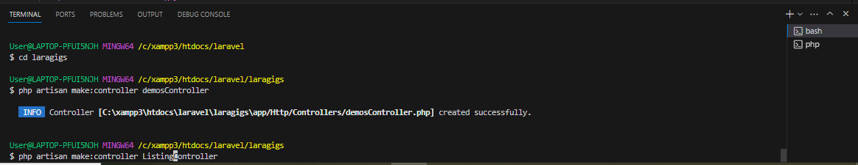

Then it will create an new controller file at “app/http/controller”

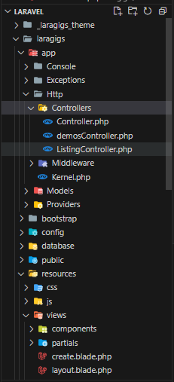

Step 2:

At the top of the ListingController.php add

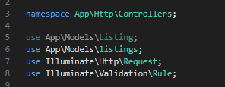

Make sure link with the modal listing

Between the class ListingController, add the code bellow

Step 3:next go to the listings modal and add the following code:

Step 4:

Go to the “route/web.php”

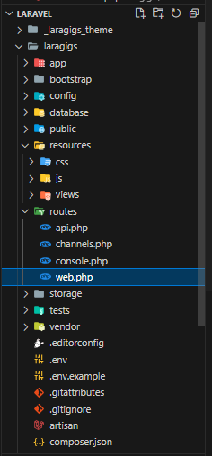

And add the following code:

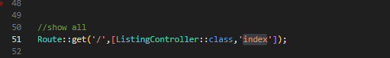

Step 5: now you can run the function page

When you search any word inside the textbox it will return the match data of the title or description or tag

